Q1

Variables:

Let Xi be the quarterly production in i-th quarter during regular-time labor, and Yi be the quarterly production in i-th quarter during over-time labor, where i = 1, 2, 3.

Let Zi be the quarterly inventory for i-th quarter, i = 1, 2, 3.

Objective: minimize total cost: $40×\sum_{i=1}^{3}{X_{i}}+ 60×\sum_{i}^{3}{Y_{i}}+15×\sum_{i}^{3}{Z_{i}}$

Constraints:

$0.8{(X}_{1}+Y_{1})+20-Z_{1}≥30$ (Demand for quarter 1)

$0.8{(X}_{2}+Y_{2})+{0.9Z}_{1}-Z_{2}≥20$ (Demand for quarter 2)

$0.8(X_{3}+Y_{3})+{0.9Z}_{2}-Z_{3}≥40$ (Demand for quarter 3)

$X_{i} ≤27 ∀i$ (regular time labor constraint)

$Z_{i}, X_{i}, Y_{i} ≥0 ∀i$ (non-negativity constraint)

Solution:

Used Gurobipy in Python. Results are shown below

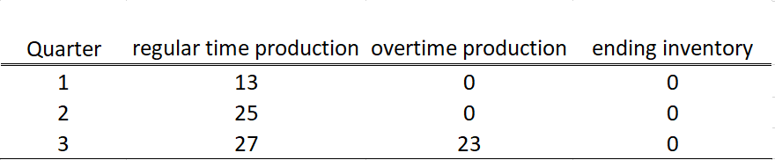

Optimal cost was minimized at a value of $3980.

Q2

Variables:

Let Xi be the number of product i produced in each week, where i = 1, 2, 3.

Let Yi be the number of workers working on machine i, where i = 1, 2, 3.

Objective: max profit: 6X1 + 8X2 + 10X3

Constraints:

$2X_{1}+3X_{2}+4X_{3}≤5×40$ (machine 1 operating constraint)

$3X_{1}+5X_{2}+6X_{3}≤3×40$ (machine 2 operating constraint)

$4X_{1}+7X_{2}+9X_{3}≤4×40$ (machine 3 operating constraint)

$Y_{1}+Y_{2}+Y_{3}≤10$ (worker constraint)

$9x_{1}+15x_{2}+19x_{3} <= 350$ (Working time constraint)

Y1<= 5, Y2<=3, Y3<=4 (Upper bound)

$2X_{1}+3X_{2}+4X_{3}=35×Y_{1}$ (Working time for machine 1)

$3X_{1}+5X_{2}+6X_{3}=35×Y_{2}$ (Working time for machine 2)

$4X_{1}+7X_{2}+9X_{3}=35×Y_{3}$ (Working time for machines 3)

$X_{i}, Y_{i} ≥0 ∀i$ (non-negativity)

Solution:

Used Gurobipy in Python, Results are shown below.

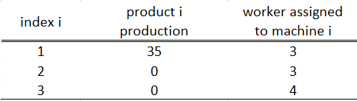

Optimal profit was maximized at $210.

Q3

Variables:

Let Xi be the amount invested in 1 year investment for i-th year, and Yi be the amount invested in 3 years investment for i-th year, and Zi be the amount invested in 5 years investment for i-th year.

Objective: max sixth year return: $0.051X_{6}+0.162Y_{4}+0.285Z_{2}$

Constraints:

$X_{1}+Y_{1}+Z_{1}=10000$ (constraint for initial investment)

$X_{2}+Y_{2}+Z_{2}≤0.051X_{1}$ (constraint for second year investment)

$X_{3}+Y_{3}≤0.051X_{2}$ (constraint for third year investment)

$X_{4}+Y_{4}≤0.051X_{3}+0.162Y_{1}$ (constraint for fourth year investment)

$X_{5}≤0.052X_{4}+0.162Y_{2}$ (constraint for fifth year investment)

$X_{6}≤0.051X_{5}+0.162Y_{3}+0.285Z_{1}$ (constraint for sixth year investment)

$X_{i}, Y_{i}, Z_{i}≥0 ∀i$ (non-negativity constraint)